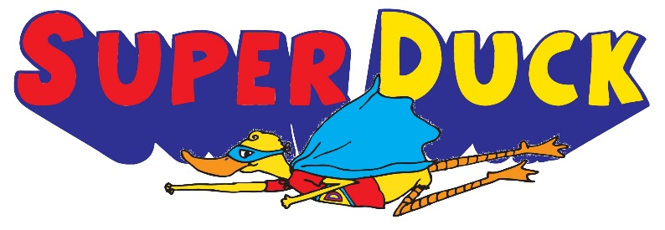

T-Shirts - $15
If you would like to buy a shirt (optional!), please return this form to
Mr. Strickland or the elementary office with payment (Cash or check payable to FPD) by Thursday, September 3. If you lose the form or want to order multiple shirts, feel free just to write the information below on a sheet of paper. Feel free to order shirts for family members or friends if you would like to help spread the word about the show!

Name___________________________________________ Grade______________

Teacher_________________________________________

Size (please circle): Youth Small Youth Medium Youth Large

Adult Small Adult Medium Adult Large

Adult X-Large Adult 2X-Large

