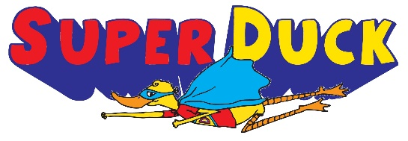
Super Duck
Audition Form

Audition Dates:
Wednesday, August 19, 3:15 – 5:15 PM
Thursday, August 20, 3:15 – 5:15 PM

I strive to make the auditions fun and low-stress for young performers. We will be playing some acting games, doing a short warm-up, performing a movement exercise, and reading from the script. Friends and family members are NOT allowed to watch the auditions (it becomes very distracting for the kids and often keeps them from doing their best), but are welcome to wait for their child in the auditorium lobby.

Name:_____________________________________________________ Grade:__________

Parent/Guardian’s Name:______________________________________________________

Phone(s):______________________________ E-Mail:________________________________

Teacher:______________________________________________________________________

Hair Color:______________________________ Age:_____________ T-Shirt Size:__________

Previous theatre and performing experience:

Other special abilities and talents:

(Don’t forget to fill out the back!)
Super Duck will be performed September 22 and 24 at 7:00 PM in the Clark Fine Arts Center. There will also be a 1:00 PM school performance scheduled on Wednesday, September 23. To audition for this play you MUST be available for all performances.

Rehearsals for Super Duck will be held after school from 3:15 – 5:00 PM, Monday through Thursday. No rehearsals are held on weekends. The week before the show we will rehearse until 5:30 every day (including Friday but still no weekends) and have at least one evening rehearsal. Not every child is called to every rehearsal. I only schedule students for rehearsal when they will actively be needed! However, students with many after-school activities may not have the necessary time to commit to this production.

Please list any conflicts that your child has with these rehearsal times and any additional extra-curricular activities they are participating in this semester. Please be as specific as possible – I will use this information to create the rehearsal schedule.

Schedule Conflicts/Extra-Curricular Activities:

I certify with my signature that my child is available for ALL performances and that I have listed all of his/her schedule conflicts to the best of my ability. I also give my child permission to audition for and perform in this production of Super Duck.

Signature:____________________________________________________________________

THIS SHEET MUST BE COMPLETED AND TURNED IN TO MR. STRICKLAND
AT AUDITIONS! Do not give it to your teacher!

Need more information? Ask Mr. Strickland!

